ELECENG 3CL4 – Lab 3
Proportional Control & Proportional with Velocity
Feedback Control of DC Motor Servomechanism

March 6th, 2026

Amaiam Ul Haque – haquea24 – 400520641 – L07 – C02
Jumana Ismail – ismailj – 400507846 – L07 – C02

Plagiarism Statement
As a future member of the engineering profession, the student is responsible for performing the required work in an honest manner, without plagiarism and cheating. Submitting this work with my name and student number is a statement and understanding that this work is my own and adheres to the Academic Integrity Policy of McMaster University and the Code of Conduct of the Professional Engineers of Ontario. Submitted by [Amaiam Ul-Haque, haquea24, 400520641]
As a future member of the engineering profession, the student is responsible for performing the required work in an honest manner, without plagiarism and cheating. Submitting this work with my name and student number is a statement and understanding that this work is my own and adheres to the Academic Integrity Policy of McMaster University and the Code of Conduct of the Professional Engineers of Ontario. Submitted by [Jumana Ismail, ismailj, 400507846]

Individual Contributions

Introduction
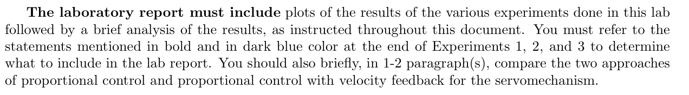
The laboratory report must include plots of the results of the various experiments done in this lab followed by a brief analysis of the results, as instructed throughout this document. You must refer to the statements mentioned in bold and in dark blue color at the end of Experiments 1, 2, and 3 to determine what to include in the lab report. You should also briefly, in 1-2 paragraph(s), compare the two approaches of proportional control and proportional control with velocity feedback for the servomechanism.

Experiment 1: Proportional Controller Trade-off in Risetime, Percentage Overshoot, and Steady-state Error

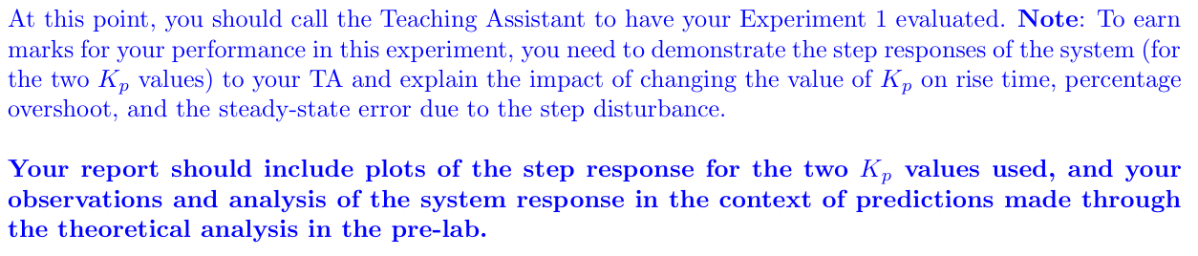

 | $$K_{p}=1$$ | $$K_{p}=5$$
$$f_{v}$$ | $$1.62$$ | $$1.506$$
$$T_{r1}$$ | $$t_{1}: 10\%=0.1f_{v}=0.162≈ 0.718 \\ t_{1}=0.03s$$  $$t_{2}: 90\%=0.9f_{v}=1.458≈1.470 \\ t_{2}=0.106s$$  $$T_{r1} \\ =t_{2}-t_{1} \\ =0.106-0.03 \\ =0.103s$$ | $$t_{1}: 10\%=0.1f_{v}=0.1506≈ 0.1595 \\ t_{1}=0.015s$$  $$t_{2}=90\%=0.9f_{v}=1.3554≈1.295 \\ t_{2}=0.04s$$  $$T_{r1} \\ =t_{2}-t_{1} \\ =0.04-0.015 \\ =0.025s$$
$$M_{p}$$ | $$2.151$$ | $$2.534$$
$$P.O$$ | $$P.O \\ =\frac{M_{p}-f_{v}}{f_{v}}×100 \\ =\frac{2.151-1.62}{1.62}×100 \\ =32.8\%$$ | $$P.O \\ =\frac{M_{p}-f_{v}}{f_{v}}×100 \\ =\frac{2.534-1.506}{1.506}×100 \\ =68.26\%$$
$$e_{ss}$$ | $$e_{ss} \\ =f_{v}-A_{input} \\ =1.62-1.5 \\ =0.12$$ | $$e_{ss} \\ =f_{v}-A_{input} \\ =1.506-1.5 \\ =0.006$$
$$plot$$ | ***insert Simulink graph*** | ***insert Simulink graph***

Experiment 2: Proportional Servo Controller

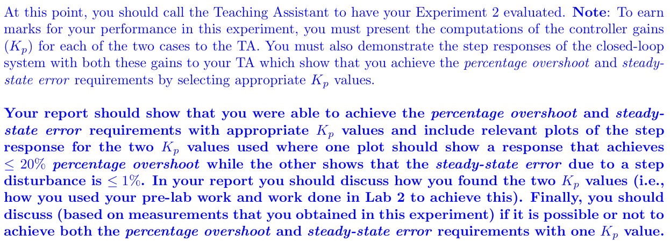
Specific motor parameters determined from Lab 2:
$$ζ=0.1504 \\ ω_{n}=35.3038 \\ τ_{m}=0.0941s \\ A=29.3392$$

Calculating $K_{p}$ for achieving $<20\% P.O$:
Using equation from Prelab question 5:
$$P.O=100e^{\frac{-π}{\sqrt{4K_{p}Aτ_{m}}-1}} \\ 20\%>100e^{\frac{-π}{\sqrt{4K_{p}Aτ_{m}}-1}}$$
$$k_{p}>\frac{{\frac{-π}{\ln\left(0.2\right)}}^{2}+1}{4Aτ_{m}} \\ k_{p}>\frac{{\frac{-π}{\ln\left(0.2\right)}}^{2}+1}{4\left(29.3392\right)\left(0.0941\right)} \\ k_{p}>0.43558$$This value of $k_{p}$ leads to the following values with the Simulink model:
$$f_{v}=1.899 \\ M_{p}=2.074$$
$$P.O \\ =\frac{M_{p}-f_{v}}{f_{v}}×100 \\ =\frac{2.074-1.899}{1.899}×100 \\ =9.22\%$$

$$e_{ss} \\ =f_{v}-A_{input} \\ =1.889-1.5 \\ =0.399$$

Finding $K_{p}$ for achieving $<1\% e_{ss}$:
$$e_{ss}<0.01A_{input} \\ e_{ss}<0.01\left(1.5\right) \\ e_{ss}<0.015$$
$$e_{ss}=f_{v}-A_{input}$$
$$0.015>f_{v}-A_{input} \\ 0.015>f_{v}-1.5 \\ f_{v}<1.515$$
Experimentally finding $K_{p}$ with $f_{v}<1.515$:
 | Experimental $k_{p}$ | Resulting $f_{v}$
Attempt #1 | $$k_{p}=5$$ | $$f_{v}=1.506$$
Attempt #2 | $$k_{p}=4.5$$ | $$f_{v}=1.571$$
Attempt #3 | $$k_{p}=4.75$$ | $$f_{v}=1.528$$
Attempt #4 | $$k_{p}=4.99$$ | $$f_{v}=1.516$$
Attempt #5 | $$k_{p}=4.995$$ | $$f_{v}=1.506$$
Attempt #6 | $$k_{p}=4.991$$ | $$f_{v}=1.509\sim 1.515$$

With the experimentally determined value of $k_{p}=4.991$:
$$f_{v}=1.509 \\ M_{p}=2.537 \\ P.O=\frac{M_{p}-f_{v}}{f_{v}}×100 \\ =\frac{2.537-1.509}{1.509}×100 \\ =69.13\%$$

Experiment 3: Proportional Controller with Velocity Feedback

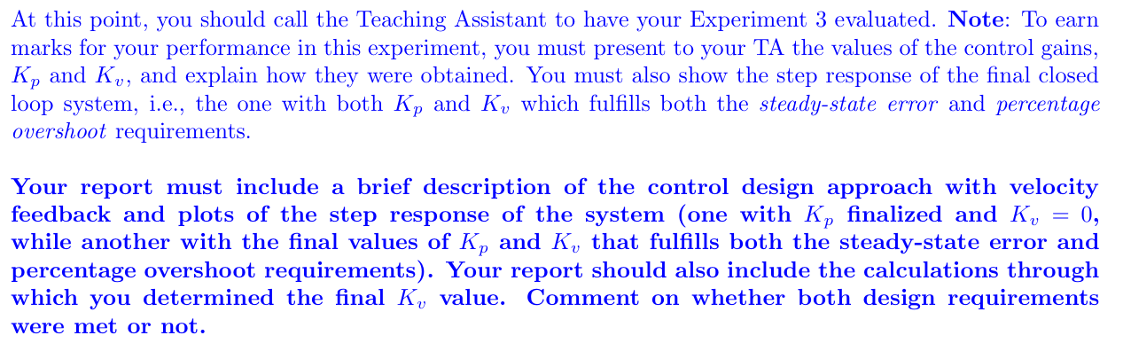

Finding $K_{p}$ for achieving $<1\% e_{ss}$:
A value of $k_{p}=4.991$ results in $e_{ss}<1\%$, just as determined in experiment 2.
***insert graph from experiment 2 its practically the same as when k_v=0***

Finding $K_{v}$ for achieving $<10\% P.O$:
$$ζ=\frac{-\ln\left(P.\frac{O}{100}\right)}{\sqrt{π^{2}+\ln^{2}\left(P.\frac{O}{100}\right)}} \\ ζ=\frac{-\ln\left(\frac{10}{100}\right)}{\sqrt{π^{2}+\ln^{2}\left(\frac{10}{100}\right)}} \\ ζ=0.5912$$
Using equation 17:
$$ζ=\frac{1+k_{v}A}{2\sqrt{k_{p}Aτ_{m}}} \\ k_{v}=\frac{2ζ\sqrt{k_{p}Aτ_{m}}-1}{A} \\ k_{v}=\frac{2\left(0.5912\right)\sqrt{\left(4.991\right)\left(29.3392\right)\left(0.0941\right)}-1}{29.3392} \\ k_{v}=0.1155$$

***insert graph with kp and kv***

